HF / Oceanic Procedures
Quick Reference Guide
Contents

Domestic U.S. HF Radio Check

Example Radio Calls

Position Reporting

Position Reporting Form

SELCAL Codes Table

Weather Deviation

Revision Status
001 | Original Issue
002 | Added clickable links, more communication examples, and section on weather deviations.
003 | Enhanced communications examples. Format changes. Added revision status page. Updated ARINC maps.
004 | Added examples for compulsory reporting points.

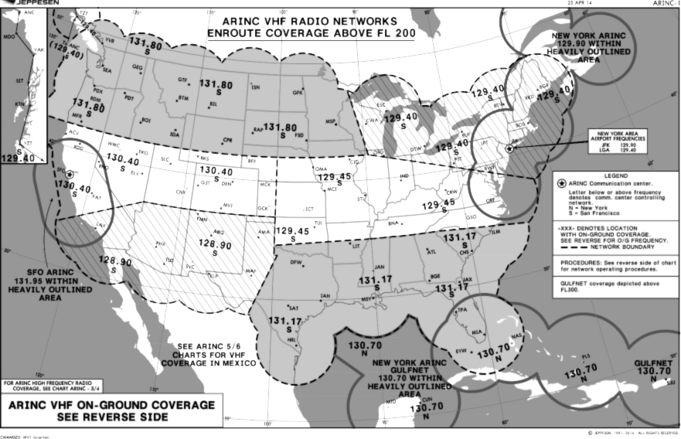
Domestic U.S. HF Radio Check
ARINC 13393 rev. X, Item 2.2.1.5

An HF radio check can be made on the ground or while airborne.

The HF radio check should be made:
- Prior to departure, or
- Prior to entering U.S. oceanic airspace

For any HF radio check:
- Using the ARINC-1 chart, determine your location and the most suitable ARINC facility
- Note the S or N below each listed frequency.
  - S (SFO) San Francisco
  - N (NYC) New York
- For a ground-based check, call the appropriate agency by phone using the numbers in the table below.
- For an airborne check, use the appropriate charted VHF frequency (from ARINC-1)

ARINC Agency | Primary Phone | Secondary Phone
San Francisco Radio | (800) 621-0140 | (925) 294-8297
New York Radio | (631) 589-7272 | (631) 244-2483

Provide the following information:

 | Example:
Aircraft Location | Cedar Rapids, IA, KCID
Callsign | N845TM
SELCAL | BC-GL
Destination | Trinidad-Tobago

Request PRIMARY and SECONDARY frequency for HF radio check.
Tuning The HF Radio
Honeywell | Collins
- Select USB (Upper Side Band) on the outer tuning knob.  - Push the inner tuning knob to select each place, rotate knob to change frequency.  - Select channel, dial frequency, press STORE | - Use TUNE page 2, enter frequency in format xx.xxx
- Press PTT once to tune antenna | - Press PTT once to tune antenna

Position Reporting
“Radar service terminated.”
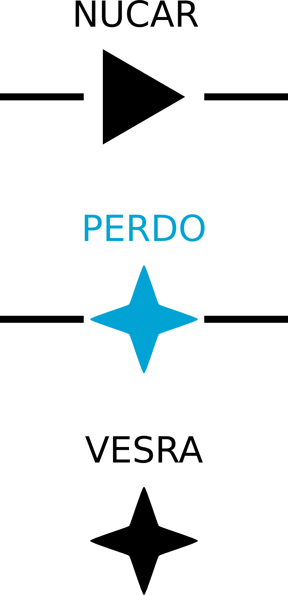
Be sure to monitor 121.5 and 123.45 as necessary.

Only required to report over compulsory reporting points:
- Solid stars (Jeppesen)
- Solid triangles (NACO)

Upon hearing “RADAR contact”, no longer required to make position reports unless requested by ATC.

Remember, you are not talking directly to ATC. You are talking to a radio operator who acts as a relay between you and ATC. Give them plenty of time to respond as they may be very busy.

Position Reporting Format |  |  |  | Optional
“OVER” | FIX NAME 1 | TIME [Z] | ALTITUDE | SPEED, FUEL
“ESTIMATING” | FIX NAME 2 | TIME [Z]
“NEXT” | FIX NAME 3

Example Radio Calls

N845TM | New York Radio, New York Radio, N845TM Position.
NYR | N845TM, go ahead.
N845TM | N845TM OVER FIX1, TIME, ALT, MACH, ESTIMATING FIX2, TIME, NEXT FIX3.
NYR | N845TM OVER FIX1, TIME, ALT, MACH, ESTIMATING FIX2, TIME, NEXT FIX3.
N845TM | Readback correct.

When transitioning from VHF to HF, the VHF controller will issue the HF PRIMARY and SECONDARY or a VHF ARINC frequency where you can get a PRIMARY and SECONDARY.

When transitioning from HF to VHF, the HF controller will tell you to:
“Contact [XYZ Center] on XXX.XXX upon reaching [FIXNAME]”

Alternatively, they may issue a:
“Contact [XYZ Center] on XXX.XXX NN (miles or minutes) prior to [FIXNAME]”

Weather Deviation
TMC Intl Ops Manual, 4.3.2
Weather Deviation Procedures in Oceanic Airspace, p. 4-4

If you can establish contact with ATC:
- Try to obtain an ATC clearance prior to deviating.
- Use the phraseology, “WEATHER DEVIATION IS REQUIRED”
- If your situation is urgent, “PAN PAN, PAN PAN, PAN PAN”
- Advise when deviation is no longer required.

If you cannot establish contact with ATC:
- Deviate away from an organized track system.
- Communicate at suitable intervals on 121.5 and/or 123.45:
  - Flight Identification
  - Flight Level
  - Aircraft Position (route, track code, as appropriate)
  - Intentions
- Watch for conflicting traffic (be sure TCAS is on)
- Turn on exterior lights (adhere to aircraft limitations)
- For deviations less than 10 NM from centerline, aircraft should remain at the level assigned by ATC.
- When the aircraft is approximately 10 NM from track, initiate a level change based on the following criteria:

ROUTE CENTERLINE  and/or TRACK | DEVIATIONS  > 10 NM | LEVEL  CHANGE
East 000 – 179  Magnetic | LEFT of course  RIGHT of course | DESCEND 300'  CLIMB 300'
West 180 – 359  Magnetic | LEFT of course  RIGHT of course | CLIMB 300'  DESCEND 300'
When returning to track, be at assigned Flight Level when the aircraft is within approximately 10 NM of centerline.

- If contact was not established prior to deviating, continue to attempt to contact ATC to obtain a clearance. If contact was established, continue to keep ATC advised of intentions, and obtain Essential Traffic Information.
SELCAL Codes Table
Hawker |  | Challenger
401TM | BHCD | 610TM | MSAH
403CT | BJCQ | 620TM | EHPR
404TM | EKGJ
405TM | BJCQ
406TM | CPGS
417TM | BHCD
426TM | EKGJ
427TM | ELHM
429TM | AGJP
806TM | GSAM
808TM | GSAK
818TM | GSCK
820TM | BRES
822TM | BHCD
830TM | AGJP
833TM | BRFG
835TM | ELHM
840TM | EKGJ
845TM | BHCD
855TM | AGJP
860TM | ELHM
865TM | EKGJ
870TM | BHCD
875TM | AGJP
877TM | BRFJ
880TM | ELHM
885TM | BJCQ
890TM | BJCQ
895TM | AGJP
899TM | DSAQ

Sample Oceanic/HF Position Reporting Form

SELCAL |  | MACH |  | NOTES  PRI / SEC / VHF
FIX | ETA | ATA | FL | NOTES  PRI / SEC / VHF

